**EMBEDDED AI TASK-ROCK PAPER SCISSOR DETECTION**

**Start the first cell by an run the command**

!nvidia-smi

**Install Yolov8:**

# Pip install method (recommended)

!pip install ultralytics==8.2.103 -q

from IPython import display

display.clear_output()

import ultralytics

ultralytics.checks()

from ultralytics import YOLO

from IPython.display import display, Image

**Import dataset:**

!mkdir -p {HOME}/datasets

%cd {HOME}/datasets

!pip install roboflow

from roboflow import Roboflow

rf = Roboflow(api_key="h53Ls4KyHtrJzcUe9y2Z")

project = rf.workspace("roboflow-58fyf").project("rock-paper-scissors-sxsw")

version = project.version(14)

dataset = version.download("yolov8")

**Custom Train:**

%cd {HOME}

!yolo task=detect mode=train model=yolov8s.pt data={dataset.location}/data.yaml epochs=25 imgsz=800 plots=True

f%cd {HOME}

Image(filename=f'{HOME}/runs/detect/train/confusion_matrix.png', width=600)

%cd {HOME}

Image(filename=f'{HOME}/runs/detect/train/val_batch0_pred.jpg', width=600)

Output:(Train)

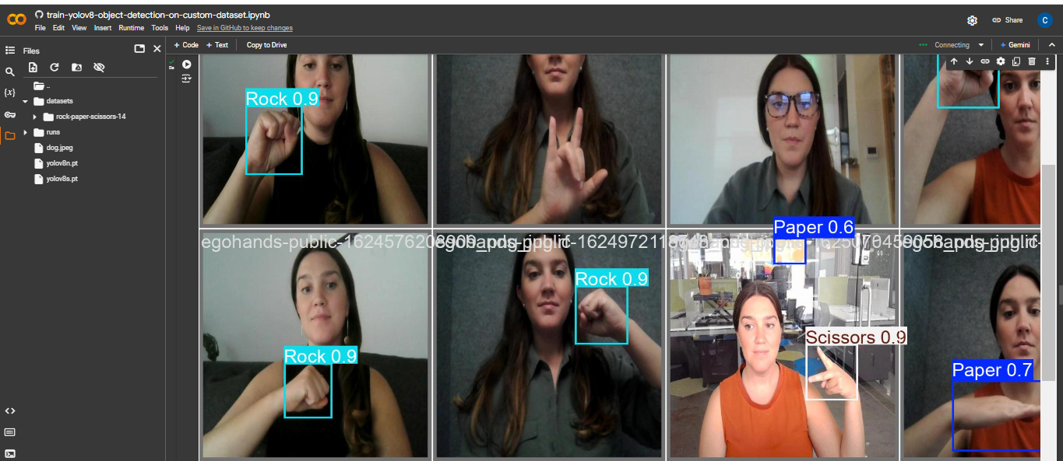

**Validate Custom Model:**

%cd {HOME}

!yolo task=detect mode=val model={HOME}/runs/detect/train/weights/best.pt data={dataset.location}/data.yaml

Output:

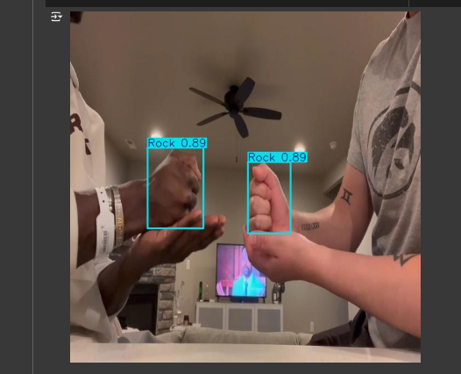

**Presented by**

Ganga devi S-22cs025

Poovish Raja-22cs064

Prem Kumar-22cs068

Rahul-22CSL09